

LUMEN 4 VW

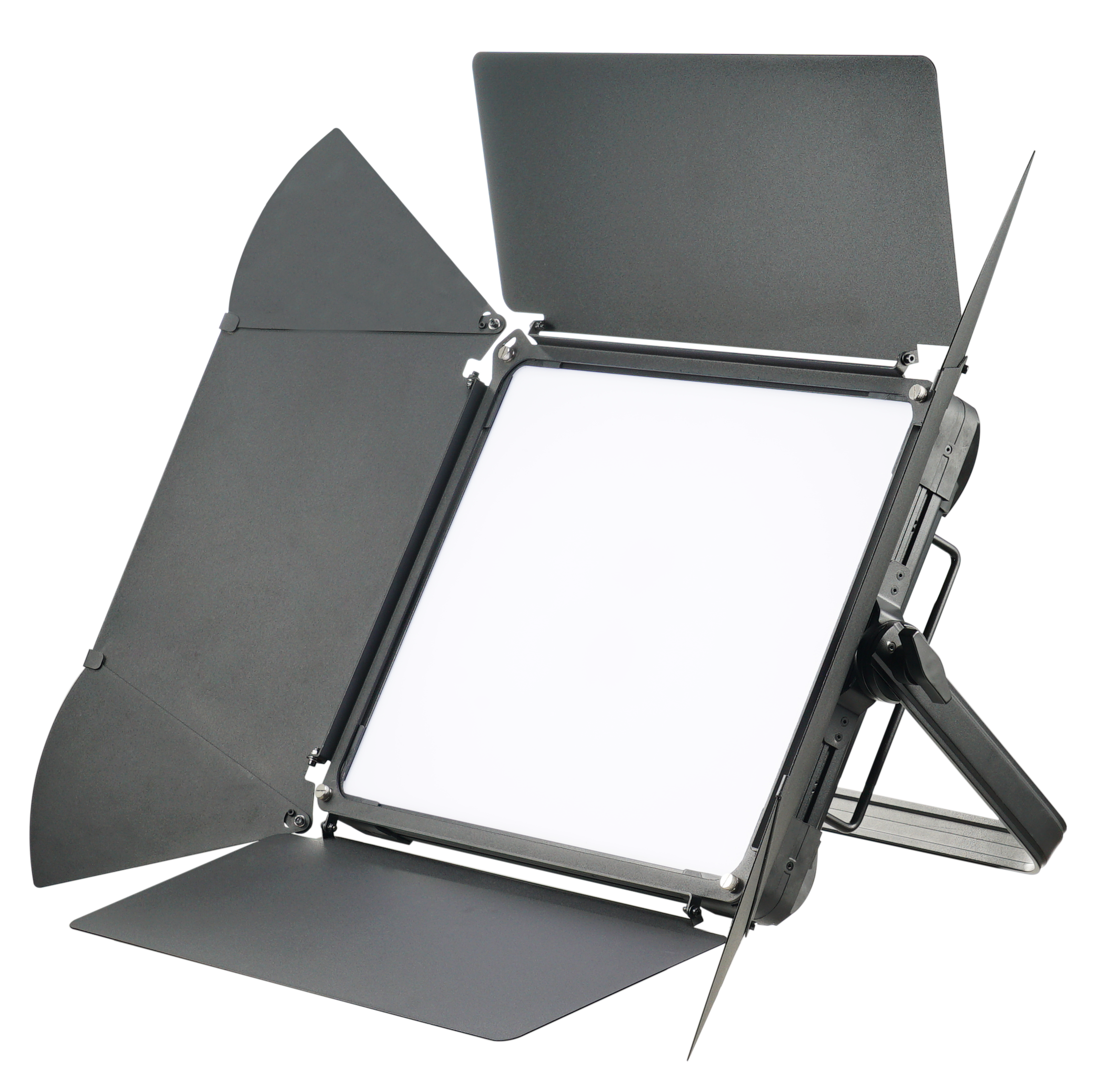

User Manual
Please read the instructions carefully before use

CONTENTS

1. Safety Introductions 2
2. Technical Specifications 3
3. How To Set The Fixture 4
3.1 Control Panel 4
3. 2 The Plate for Barn Door Installation 5
4. How To Control The Unit 10
4.1 Master/Slave Function 10
4.2 DMX Controller 10
4.3. DMX512 Configuration 11
4.4. DMX512 Connections 14
5. Troubleshooting 15
6. Fixture Cleaning 15

1. Safety Introductions

Please read the instructions carefully which includes important information about the installation, operation and maintenance.
WARNING
Please keep this User Manual for future consultation. If you sell the unit to another user, be sure that they also receive this instruction booklet.
- Unpack and check carefully there is no transportation damage before using the unit.
- Before operating, ensure that the voltage and frequency of power supply match the power requirements of the unit.
- It’s important to ground the yellow/green conductor to earth in order to avoid electric shock.
- The unit is for indoor use only. Use only in a dry location.
- The unit must be installed in a location with adequate ventilation, at least 50cm from adjacent surfaces. Be sure that no ventilation slots are blocked.
- Disconnect main power before replacement or servicing.
- Make sure there are no flammable materials close to the unit while operating as it is fire hazard.
- Use safety cables when fixing this unit.
- Maximum ambient temperature is Ta: 40 degrees C. DO NOT operate it where the temperature is higher than this.
- Turn off the power and allow about 15 minutes for the unit to cool down before servicing.
- In the event of a serious operating problem, stop using the unit immediately. Never try to repair the unit by yourself. Repairs carried out by unskilled people can lead to damage or malfunction. Please contact the nearest authorized technical assistance center. Always use the same type spare parts.
- DO NOT touch any cables during operation as high voltage may cause electric shock.

Warning:
- To prevent or reduce the risk of electrical shock or fire, do not expose the unit to rain or moisture.
- The housing and lenses must be replaced if they are visibly damaged.

Caution:
There are no user serviceable parts inside the unit. Do not open the housing or attempt any repairs yourself. In the unlikely event your unit may require service, please contact your nearest dealer.

Installation:
The unit should be mounted via its screw holes on the bracket. Always ensure that the unit is firmly fixed to avoid vibration and slipping while operating. Make sure that the structure to which you are attaching the unit is secure and is able to support a weight of 10 times of the unit’s weight. Also always use a safety cable that can hold 12 times of the weight of the unit when installing the fixture.
The equipment must be installed by professionals. It must be fixed at a place where is out of the reach of people and no one pass by or under it.

2. Technical Specifications
Power Voltage: AC 100 ~ 240V, 50/60Hz
 Power Consumption: 199W
 Light Sources: 480pcs CW + 480pcs WW LED
 Color Temperature: 3200±150K
5600±150K
 Beam angle: 130°
 CRI： ≥94
 Weight: 13Kgs
 Dimension: 668 x 491.4 x 147.5mm
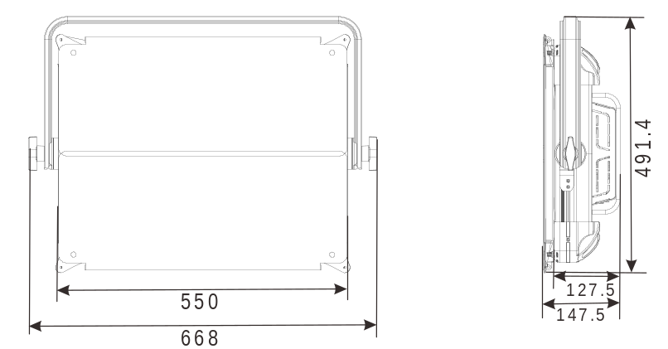

3. How To Set The Fixture

3.1 Control Panel
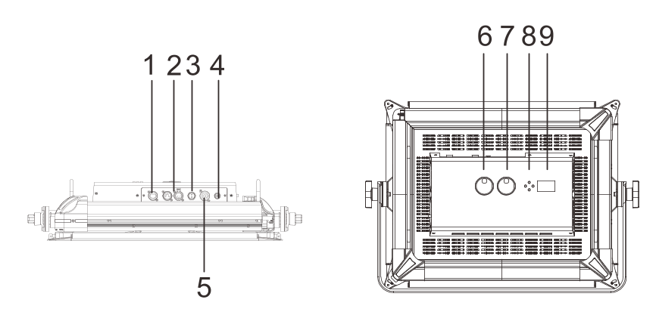
- ETHERNET: Connect with the multimedia and use software to control the units via ArtNet;
- DMX IN/OUT : For DMX 512 link, use 5-pin XLR cable to link the unit to a DMX controller or the next unit and output DMX signal;
- Battery DC48V: Connects to external battery;
- Fuse (T5A): To protect the unit from damage of over current;
- Mains In: Connects to mains supply power;
- Color Temperature Knob: Adjust the color temperature;
- Dimmer Knob: Adjust the dimmer;
- Button:
MENU | To select the programming functions
DOWN | To go backward in the selected functions
UP | To go forward in the selected functions
ENTER | To confirm the selected functions
- Display: Shows the various menus and the selected functions.

3. 2 The Plate for Barn Door Installation
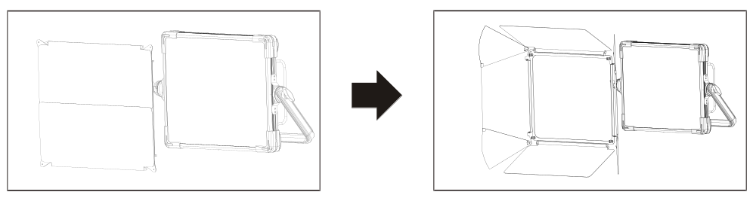
At first, please push the barn door by hand.
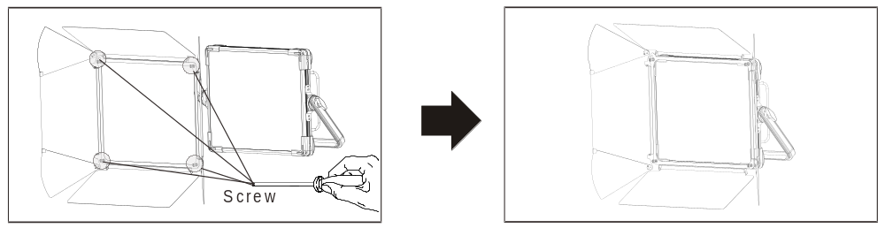
Secondly, please put the Barn Door into the unit, to fasten the screws of the slot, then finish the barn door installation.

3.3 Main Function
To select any of the given functions, press the MENU button up to the required selection as shown on the display. Select the function with the ENTER button and the display will blink. Use the DOWN/UP buttons to change the mode. Once the required mode has been selected, press the ENTER button to confirm. To go back to the main functions without any changes press the MENU button again. Press and hold the MENU button for about one second or wait for 7 seconds to exit the current mode.
The main functions are shown below:
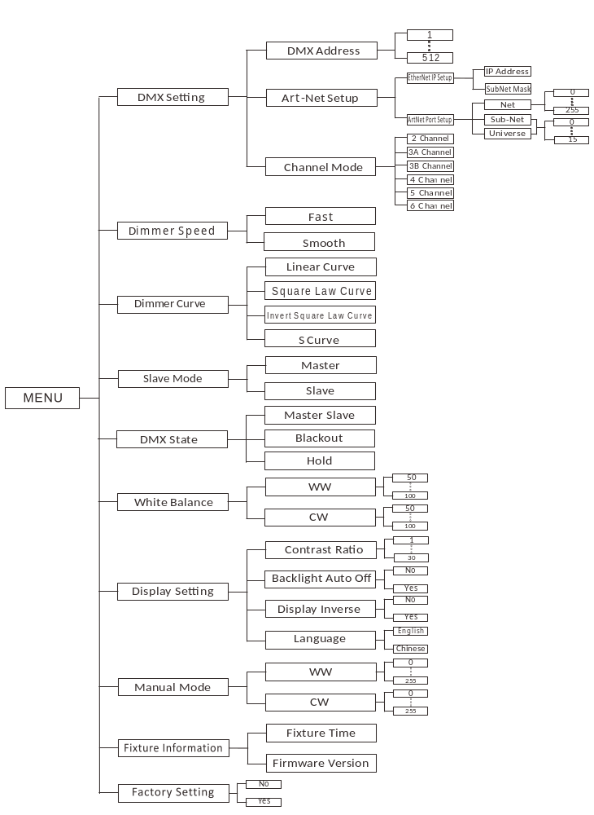

DMX Setting
Select the DMX Setting, press the ENTER button to confirm. Use the UP and DOWN button to select DMX Address, Art-Net Setup or Channel Mode.
DMX Address
Select the DMX Address, press the ENTER button to confirm, the display will show the present address. Use the UP and DOWN button to select 1 to 512, press the ENTER button to store. Press the MENU button back to the last menu or idling 30 seconds to exit menu mode.
Art-Net Setup
Select the Eth-Net Address, press the ENTER button to confirm. Use the UP and DOWN button to select the address for EtherNet IP Setup or ArtNet Port Setup, press the ENTER button to set the value for these items. Press the MENU button back to the last menu or idling 30 seconds to exit menu mode.
Channel Mode
Select the Channel Mode, press the ENTER button to confirm, the display will show the present channel mode. Use the UP and DOWN button to select 2 Channel, 3A Channel, 3B Channel, 4 Channel, 5 Channel or 6 Channel, press the ENTER button to store. Press the MENU button back to the last menu or idling 30 seconds to exit menu mode.
Dimmer Speed
Select the Dimmer Speed, press the ENTER button to confirm, use the UP and DOWN button to select the Fast or Smooth mode, press the ENTER button to store. Press the MENU button back to the last menu or idling 30 seconds to exit menu mode.
Dimmer Curve
Select Dimmer Curve, press the ENTER button to show the DIMMER CURVE on the display. Use the DOWN/UP button to select the Mode 1, Mode 2, Mode 3 or Mode 4. Once the dimmer mode has been selected, press the ENTER button to setup, to go back to the functions without any change press the MENU button again. Press and hold the MENU button for about one second or wait for one minute to exit the menu mode.

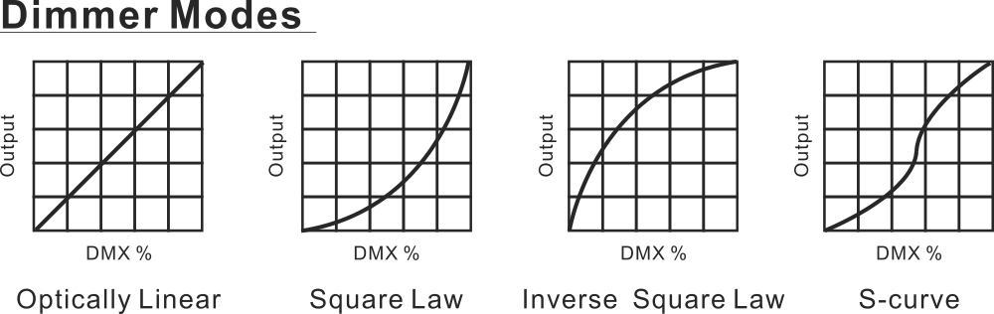
Mode 1(Optically Linear):
The increase in light intensity appears to be linear as DMX value is increased.
Mode 2(Square Law):
Light intensity control is finer at low levels and coarser at high levels.
Mode 3(Inverse Square Law):
Light intensity control is coarser at low levels and finger at high levels.
Mode 4(S-cure):
Light intensity control is finger at low levels and high levels and coarser at medium levels.
Slave Mode
Select the Slave Mode, press the ENTER button to confirm, use the UP and DOWN button to select the Master or Slave mode, press the ENTER button to store. Press the MENU button back to the last menu or idling 30 seconds to exit menu mode.
DMX State
Select DMX State, press the ENTER button to confirm, the present mode will blink on the display, use the UP and DOWN button to select Master Slave, Blackout or Hold, press the ENTER button to store. Press the MENU button back to the last menu or idling 30 seconds to exit menu mode.
White Balance
Select White Balance, press the ENTER button to confirm, the present mode will blink on the display, use the UP and DOWN button to select WW or CW and adjust the value from 50 to 100, press the ENTER button to store. Press the MENU button back to the last menu or idling 30 seconds to exit menu mode.
Display Setting
Select Display Setting, press the ENTER button to confirm, use the UP and DOWN button to select Contrast Ratio, Backlight Auto off ,Display Inverse or Language.
Contrast Ratio
Select Contrast Ratio, press the ENTER button to confirm, the present mode will blink on the display, use the UP and DOWN button to adjust from 1 to 30, press the ENTER button to store. Press the MENU button back to the last menu or idling 30 seconds to exit menu mode.
Backlight Auto Off
Select Backlight Auto Off, press the ENTER button to confirm, the present mode will blink on the display, use the UP and DOWN button to select No or Yes, press the ENTER button to store. Press the MENU button back to the last menu or idling 30 seconds to exit menu mode.
Display Inverse
Select Display Inverse, press the ENTER button to confirm, the present mode will blink on the display, use the UP and DOWN button to select No or Yes, press the ENTER button to store. Press the MENU button back to the last menu or idling 30 seconds to exit menu mode.
Language
Select Language, press the ENTER button to confirm, the present mode will blink on the display, use the UP and DOWN button to select Chinese or English, press the ENTER button to store. Press the MENU button back to the last menu or idling 30 seconds to exit menu mode.

Manual Mode
Select Manual Mode, press the ENTER button to confirm, the present mode will blink on the display, use the UP and DOWN button to select the WW or CW, press the ENTER button and use the UP and DOWN button to adjust the value from 0 ~ 255, press the ENTER button to store. Press the MENU button back to the last menu or idling 30 seconds to exit menu mode.
Fixture Information
Select Fixture Information, press the ENTER button to confirm, use the UP and DOWN button to select Fixture Time or Firmware Version.
Fixture Time
Select Fixture Time, press the ENTER button and the display will show the number of working hours of the unit. To go back to the functions press the MENU button again.
Firmware Version
Select Firmware Version, press the ENTER button and the display will show the version of firmware of the unit. To go back to the functions press the MENU button again.
Factory Setting
Select Factory Setting, press the ENTER button to confirm, the present mode will blink on the display, use the UP and DOWN button to select the No or Yes, the fixture will back to factory setting once select Yes.

4. How To Control The Unit
You can operate the unit in two ways:
1. By master/slave function
2. By DMX controller
3. By multimedia software via ArtNet
No need to turn the unit off when you change the DMX address, as new DMX address setting will be affected at once.

4.1 Master/Slave Function
By linking the units in master/slave connection, the first unit will be master automatically. You should set the master unit effect via its knobs, then the other units (slave) will lighting as the same.

4.2 DMX Controller
If you use a universal DMX controller to control the units, you have to set DMX address from 1 to 512 so that the units can receive DMX signal.
Press the MENU button to enter menu mode, select DMX Functions, press the ENTER button to confirm, use the UP/DOWN button to select DMX Address, press the ENTER button to confirm, the present address will blink on the display. Use the UP/DOWN button to adjust the address from 1 to 512, press the ENTER button to store. Press the MENU button back to the last menu or let the unit idle one minute to exit menu mode.
Please refer to the following diagram to set the address for the first 4 units.
Channel mode | Unit 1  Address | Unit 2  Address | Unit 3  Address | Unit 4  Address
2 channels | 1 | 3 | 5 | 7
3A channels | 1 | 4 | 7 | 10
3B channels | 1 | 4 | 7 | 10
4 channels | 1 | 5 | 9 | 13
5 channels | 1 | 6 | 11 | 16
6 channels | 1 | 7 | 13 | 19

4.3. DMX512 Configuration
2 Channel Mode:
CHANNEL | VALUE | FUNCTIONS
1 | 000  001 ~ 255 | COLOR TEMPERATURE  Off  5600K~3200K
2 | 000 ~ 255 | DIMMER  0  100%

3A Channel Mode:
CHANNEL | VALUE | FUNCTIONS
1 | 000 ~ 255 | WW DIMMER  0  100%
2 | 000 ~ 255 | CW DIMMER  0  100%
3 | 000 ~ 255 | DIMMER  0  100%

3B Channel Mode:
CHANNEL | VALUE | FUNCTIONS
1 | 000  001 ~ 255 | COLOR TEMPERATURE  Off  5600K~3200K
2 | 000 ~ 255 | DIMMER  0  100%
3 | 000 ~ 255 | DIMMER FINE  0  100%

4 Channel Mode:
CHANNEL | VALUE | FUNCTIONS
1 | 000 ~ 255 | WW DIMMER  0  100%
2 | 000 ~ 255 | CW DIMMER  0  100%
3 | 000 ~ 255 | DIMMER  0  100%
4 | 000 ~ 255 | DIMMER FINE  0  100%

5 Channel Mode:
CHANNEL | VALUE | FUNCTIONS
1 | 000 ~ 255 | WW DIMMER  0  100%
2 | 000 ~ 255 | CW DIMMER  0  100%
3 | 000-031  032-063  064-095  096-127  128-159  160-191  192-223  224-255 | STROBE  Off  On  Strobe: Slow  Fast  On  Strobe Pulse: Fast  Slow  On  Random Strobe  On
4 | 000 ~ 255 | DIMMER  0  100%
5 | 000 ~ 255 | DIMMER FINE  0  100%

6 Channel Mode:
CHANNEL | VALUE | FUNCTIONS
1 | 000 ~ 255 | WW DIMMER  0  100%
2 | 000 ~ 255 | CW DIMMER  0  100%
3 | 000  001 ~ 255 | COLOR TEMPERATURE  Off  5600K~3200K
4 | 000-031  032-063  064-095  096-127  128-159  160-191  192-223  224-255 | STROBE  Off  On  Strobe: Slow  Fast  On  Strobe Pulse: Fast  Slow  On  Random Strobe  On
5 | 000 ~ 255 | DIMMER  0  100%
6 | 000 ~ 255 | DIMMER FINE  0  100%

4.4. DMX512 Connections
The DMX512 is widely used in intelligent lighting control, with a maximum of 512 channels.
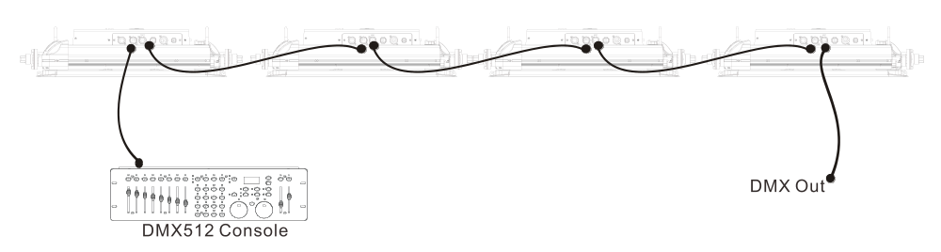
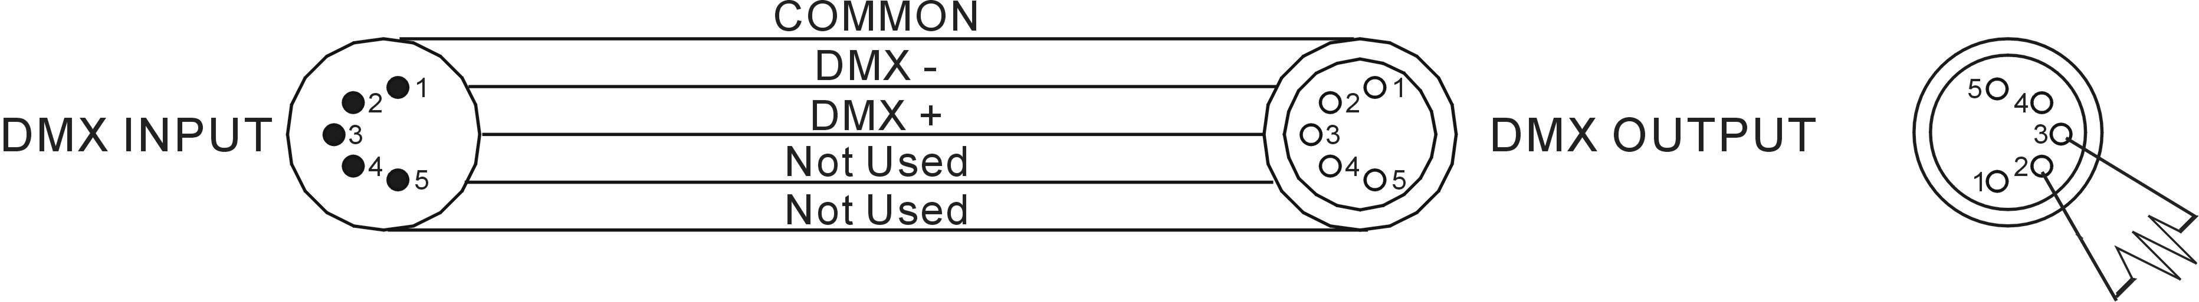

- At last unit, the DMX cable has to be terminated with a terminator. Solder a 120-ohm 1/4W resistor between pin 2(DMX-) and pin 3(DMX+) into a 3-pin XLR-plug and plug it in the DMX-output of the last unit.
- Connect the unit together in a “daisy chain” by XLR plug cable from the output of the unit to the input of the next unit. The cable cannot be branched or split to a “Y” cable. DMX 512 is a very high-speed signal. Inadequate or damaged cables, soldered joints or corroded connectors can easily distort the signal and shut down the system.
- The DMX output and input connectors are pass-through to maintain the DMX circuit, when one of the units’ power is disconnected.
- Each lighting unit needs to have a DMX address to receive the data by the controller. The address number is between 0-511 (usually 0 & 1 are equal to 1).
- The end of the DMX 512 system should be terminated to reduce signal errors.
- 3 pin XLR connectors are more popular than 5 pins XLR.
3 pin XLR: Pin 1: GND, Pin 2: Negative signal (-), Pin 3: Positive signal (+)
5 pin XLR: Pin 1: GND, Pin 2: Negative signal (-), Pin 3: Positive signal (+), Pin4, Pin5 not used.

5. Troubleshooting
Following are a few common problems that may occur during operation. Here are some suggestions for easy troubleshooting:
A. The fixture does not work, no light
- Check the connection of power and main fuse.
- Measure the mains voltage on the main connector.
B. Not responding to DMX controller
- DMX LED should be on. If not, check DMX connectors, cables to see if link properly.
- If the DMX LED is on and no response to the channel, check the address settings and DMX polarity.
- If you have intermittent DMX signal problems, check the pins on connectors or on PCB of the fixture or the previous one.
- Try to use another DMX controller.
- Check if the DMX cables run near or run alongside to high voltage cables that may cause damage or interference to DMX interface circuit.
C. One of the channels is not working well
- The stepper motor might be damaged or the cable connected to the PCB is broken.
- The motor’s drive IC on the PCB might be out of condition.

6. Fixture Cleaning
Cleaning must be carried out periodically to optimize light output. Cleaning frequency depends on the environment in which the fixture operates: moist, smoky or particularly dirty surroundings can cause a greater accumulation of dirt on the fixture.
- Clean with soft cloth using normal glass cleaning fluid or mild soapy water.
- Always dry the parts carefully.
- Clean the external optics at least every 30 days.

Declaration of Conformity

We declare that our products (lighting equipments) comply with the following specification and bears CE mark in accordance with the provision of the Electromagnetic Compatibility (EMC) Directive 89/336/EEC.

EN55103-1: 2009+A1:2012; EN55103-2: 2009;
EN61000-3-2: 2014; EN61000-3-3: 2013.

&

Harmonized Standard

EN 60598-1:2015; EN 60598-2-17:1989 + A2:1991;
EN 62471:2008; EN 62493: 2010
Safety of household and similar electrical appliances
Part 1: General requirements

Innovation, Quality, Performance

